Question 1 :

Find of the mail Server of the following domain

1 ) ibm.com

2 ) wipro.com

Ans of the Given tow domains

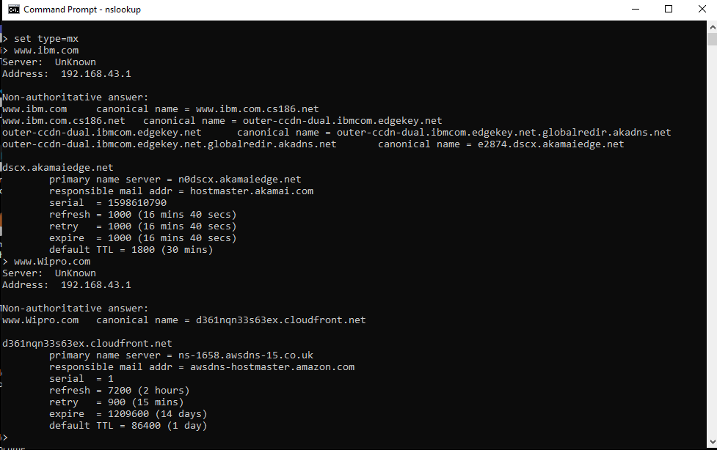

Question 2 :

Find out the Location. Where these email servers are hosted

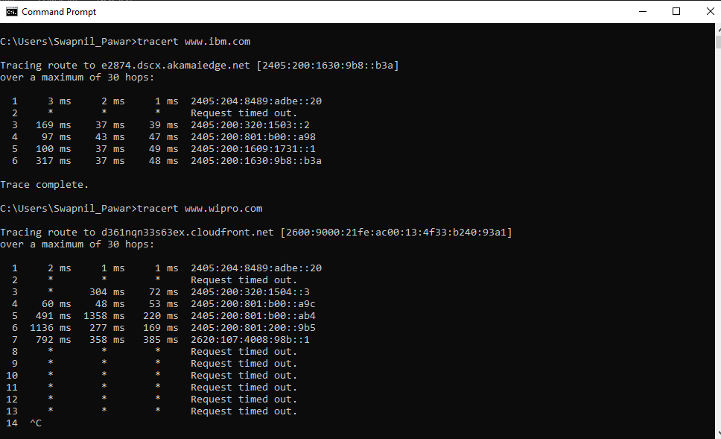

Question 3 :

Scan and find of the open port numbers 203.163.246.23

